**Screenshots of Task Performed**

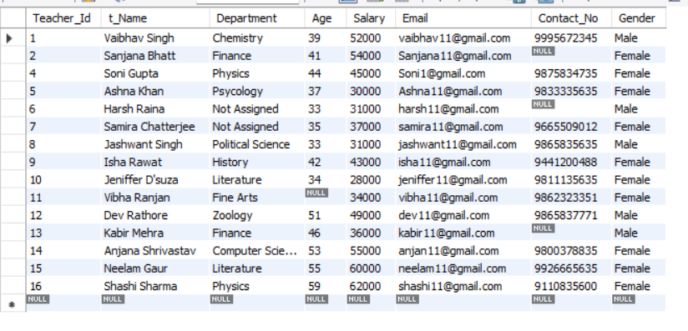

-- Extracting details using Where Clause with OR

Select t_Name, Age, Salary from teacher_details WHERE Salary >= 50000 OR Age >= 40;

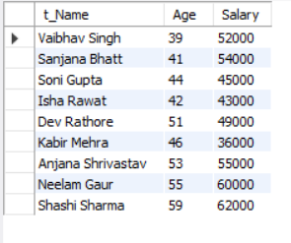

-- Extracting details using AND, BETWEEN, LIKE, ORDER BY, LIMIT, ASC and DSC

Select t_Name, Department, Salary from teacher_details WHERE Salary <= 45000 AND Department = 'Literature';

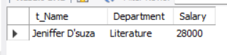

SELECT * from teacher_details WHERE Age Between 30 And 40;

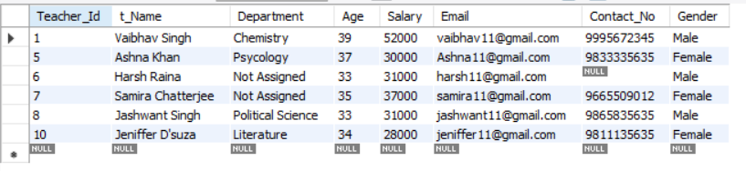

SELECT * from teacher_details WHERE Age >=50;

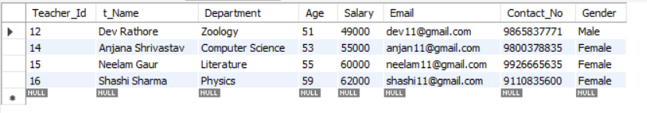

SELECT * from teacher_details WHERE t_name LIKE 'S%';

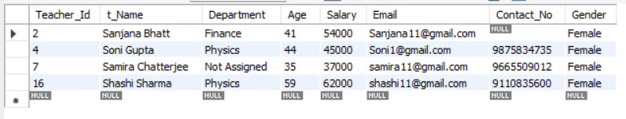

SELECT * from teacher_details ORDER BY Department ASC;

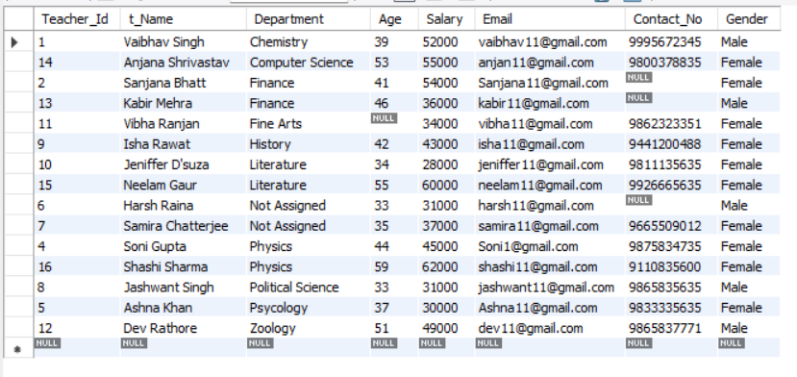

SELECT * from teacher_details LIMIT 5;

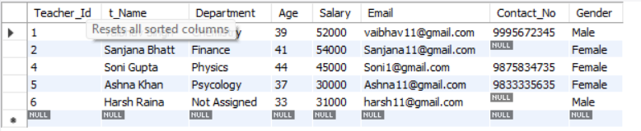

SELECT * from teacher_details ORDER BY SALARY DESC LIMIT 10;

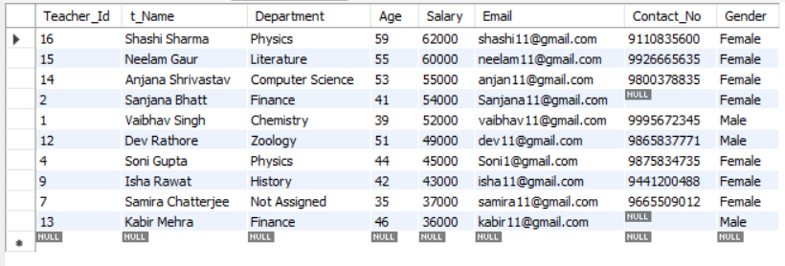

SELECT * from teacher_details WHERE GENDER= 'Male';

